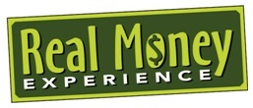
Evaluation

- Name one thing that you liked about the Real Money workshop.________________________________________________________________________________________________________________
- Name one thing that you disliked about the Real Money workshop._________________________________________________________________________________________________________________
- Was the information presented today helpful?_______________________
- What would you like to add to the workshop to make it more helpful?_________________________________________________________________________________________________________________________________________________________________________________
- Will you use the materials that you received today in your classroom?______________________________________________________________________________________________________________________________________________________________________________
- If you would like a credit union in your area to contact you about helping you in your classroom, please provide your contact information below:

Other Comments?

Thank you for coming today!

